Real-Time Food Delivery Optimization and Dispatch Engine (Food Express)


Submitted by:

Ayesha Yaseen Roll No. 2025-SE-79
Mishal Shabir Roll No. 2025-SE-70
Sanam Sana Roll No. 2025-SE-85
Maryum Arif Roll No. 2025-S-88
Submitted to:
Sir Ali Raza

Department of Computer Science
University of Engineering and Technology Lahore, New Campus

1. Introduction
FoodExpress is a food delivery platform that receives many orders during peak hours. Managing orders, kitchen load, rider assignment, and delivery routes efficiently requires proper data structures and algorithms.
This project implements a CLI-based Dispatch Engine in C++ using custom data structures (no STL containers like vector, map, or priority_queue). The system demonstrates scheduling, searching, routing, load balancing, order tracking, and performance analysis as required by the OEL manual.

2. Problem Statement
The platform faces these challenges:
- Dynamic and continuous order arrivals
- Priority-based order processing
- Overloaded restaurant preparation queues
- Inefficient rider assignment
- Changing delivery routes due to traffic or blocked roads
- Large-scale order tracking
- Performance issues as data grows
Our solution organizes data using heaps, queues, graphs, BST, linked lists, and stacks, and applies algorithms such as Dijkstra, BFS, DFS, searching, and sorting.

3. System Architecture
The system is divided into independent modules connected through the main menu.
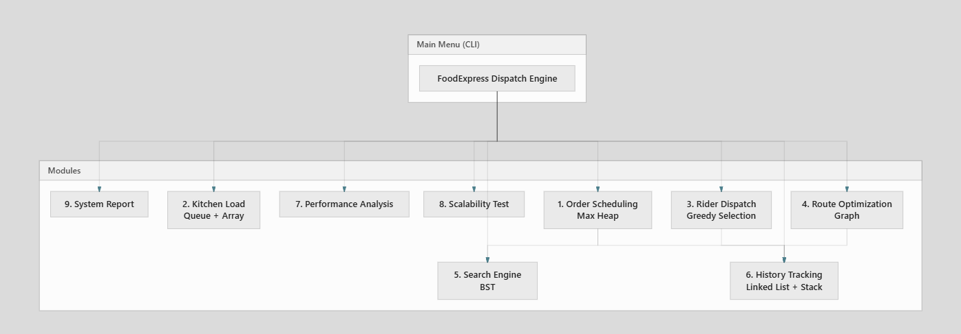

4. Module Design (Manual Requirements Mapping)

4.1 Dynamic Order Scheduling Engine
Manual Requirement: Manage dynamically arriving orders with priorities, preparation times, deadlines, customer categories, and restaurant workloads. Support insertion, cancellation, priority update, delayed handling, dynamic rescheduling, and retrieval of next processable order.
Implementation: Maxheap class
Feature | Menu Option | How It Works
Insert new order | 1 → 1 | Order inserted into max heap
View active orders | 1 → 2 | Display all heap elements
Process next order | 1 → 3 | removeMax() extracts highest priority order
Cancel order | 1 → 4 | Remove from heap, push to undo stack
Update priority | 1 → 5 | Change priority and heapify
Delay order | 1 → 6 | Reduce priority, increase deadline
Undo cancel | 1 → 7 | Pop from stack and re-insert
Dynamic Rescheduling | 1 → 8 | Update both priority and deadline, then re-heapify
Scheduling Rule: Higher priority comes first. If priority is equal, smaller deadline (more urgent) comes first.
Data Structure Justification: Max Heap gives O(log n) insertion and extraction, which is efficient for priority scheduling.

4.2 Kitchen Load Balancing Module
Manual Requirement: Restaurants have limited capacity. Distribute orders, detect overload, rebalance workload, estimate waiting time.
Implementation: Kitchen class with Restaurant struct and IntQueue
Feature | Menu Option | How It Works
View kitchen status | 2 → 1 | Show load and queue per restaurant
Complete preparation | 2 → 2 | Dequeue order from restaurant queue
Force rebalance | 2 → 3 | Assign order to least loaded kitchen
Waiting Time Estimate: currentLoad × 5 minutes (simple estimate)
Data Structure Justification: Queue (FIFO) ensures first-come-first-serve preparation at each kitchen.

4.3 Rider Dispatch and Assignment Module
Manual Requirement: Manage multiple riders. Consider location, load, availability, capacity, and distance.
Implementation: RiderMgr class
Feature | Menu Option | How It Works
Show riders | 3 → 1 | Display load and location
Assign rider | 3 → 2 | Greedy: lowest score = load×10 + distance
Complete delivery | 3 → 3 | Reduce rider load, mark DELIVERED
Data Structure Justification: Array of riders with linear scan — simple and sufficient for small number of riders.

4.4 Real-Time Route Optimization Module
Manual Requirement: City map as connected network. Shortest route, route comparison, rerouting when roads blocked, delivery cost estimation.
Implementation: Graph class (adjacency matrix)
Feature | Menu Option | How It Works
All routes from node | 4 → 1 | Dijkstra from source
Specific route | 4 → 2 | Dijkstra with path printing
Compare routes | 4 → 3 | Main route vs alternate (direct road removed)
Block road | 4 → 4 | Mark edge as blocked
Unblock road | 4 → 5 | Re-open edge
BFS traversal | 4 → 6 | Level-order graph visit
DFS traversal | 4 → 7 | Depth-first graph visit
Reroute demo | 4 → 8 | Block road, find new path, mark order REROUTED
Delivery Cost: distance × Rs. 10
Data Structure Justification: Adjacency matrix is easy to implement and suitable for a small city map (8 nodes).

4.5 Search and Retrieval Engine
Manual Requirement: Fast lookup, category-based search, filtered search, efficient record updates.
Implementation: BST class + linear search on collected data
Feature | Menu Option | How It Works
Search by Order ID | 5 → 1 | BST search — O(log n)
Search by customer | 5 → 2 | Linear search on inorder array
Search by restaurant | 5 → 3 | Linear search
Search by status | 5 → 4 | Linear search
Search by category | 5 → 5 | Linear search on active heap orders
Show all records | 5 → 6 | BST inorder traversal
Sorted report | 5 → 7 | Bubble sort on collected records
Data Structure Justification: BST gives efficient search by Order ID. Bubble sort is used for simplicity in sorted reports.

4.6 Order History and Tracking Module
Manual Requirement: Complete order history, state transitions, timeline replay, undo operations.
Implementation: HistoryList (Linked List) + OrderStack (Stack)
Feature | Menu Option | How It Works
Full history | 6 → 1 | Traverse linked list
Order timeline | 6 → 2 | Filter history by order ID
Filter by status | 6 → 3 | Show records with given status
Undo cancel | 1 → 7 | Stack pop and restore order
Order State Transitions Supported:
PLACED → QUEUED → ACCEPTED → PREPARED → ASSIGNED → PICKED → DELIVERED
↓
CANCELLED / DELAYED / RESCHEDULED / REROUTED
State | When Recorded
PLACED | Order added to system
QUEUED | Order enters scheduling heap
ACCEPTED | Order sent to kitchen
PREPARED | Order extracted from heap
ASSIGNED | Rider assigned
PICKED | Rider picks order
DELIVERED | Delivery completed
DELAYED | Order priority reduced
CANCELLED | Order cancelled
RESCHEDULED | Priority + deadline changed
REROUTED | Route changed due to blocked road
Data Structure Justification: Linked list allows easy insertion of history records. Stack supports LIFO undo for cancelled orders.

4.7 Performance Analysis Module
Manual Requirement: Evaluate insertion, deletion, searching, scheduling, route calculation, memory usage, and scalability.
Implementation: Menu 7
Feature | Menu Option
Insert performance test | 7 → 1
Delete performance test | 7 → 2
Time complexity table | 7 → 3
Memory usage analysis | 7 → 4

4.8 Scalability Simulation
Manual Requirement: Compare performance with different dataset sizes.
Implementation: Menu 8 — tests heap insertion with N = 10, 20, 50, 100

4.9 System Reports
Implementation: Menu 9 — shows active orders, kitchen status, riders, history count, and ethical considerations.

5. Class Diagram
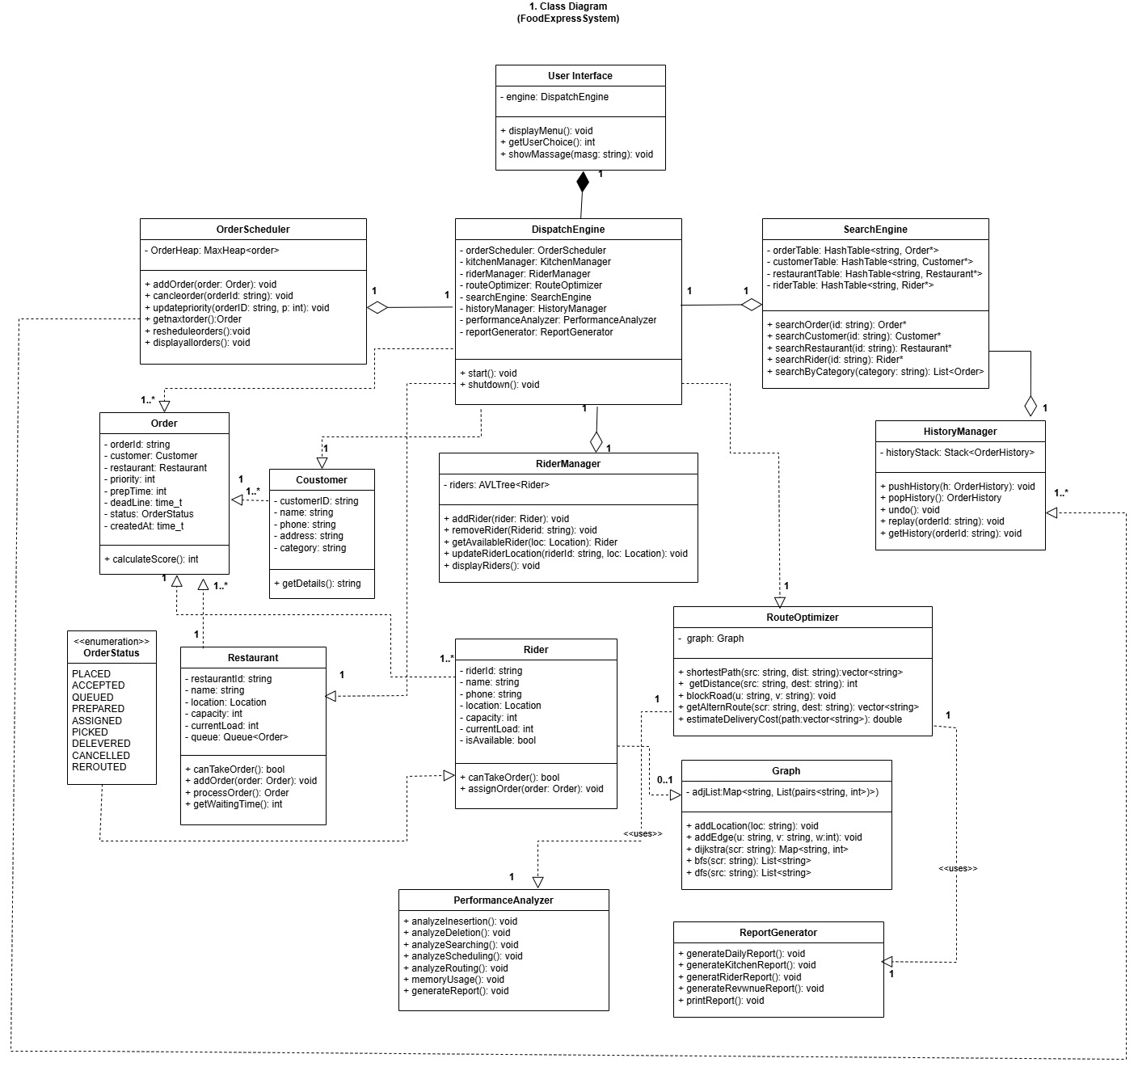

6. Flowcharts

Main Flow Diagram

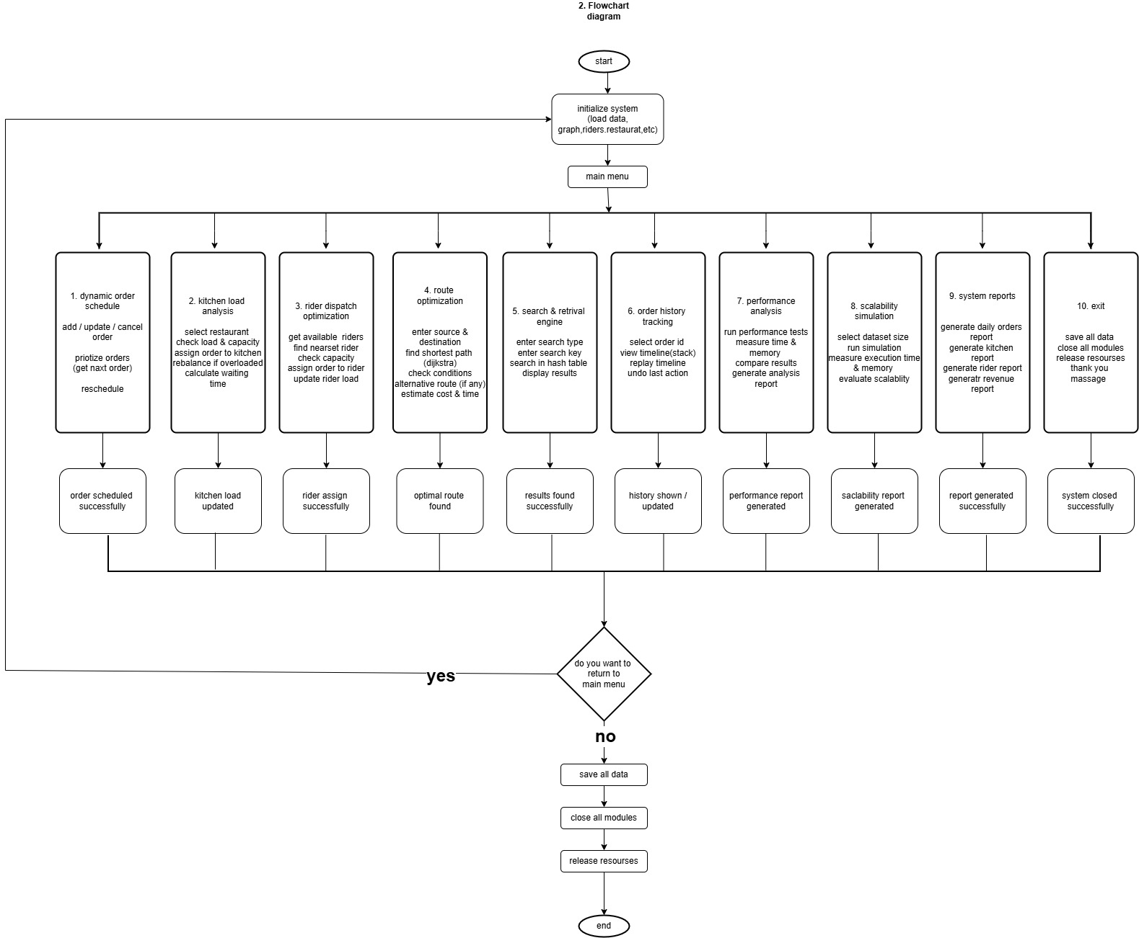

6.1 Order Processing Flow

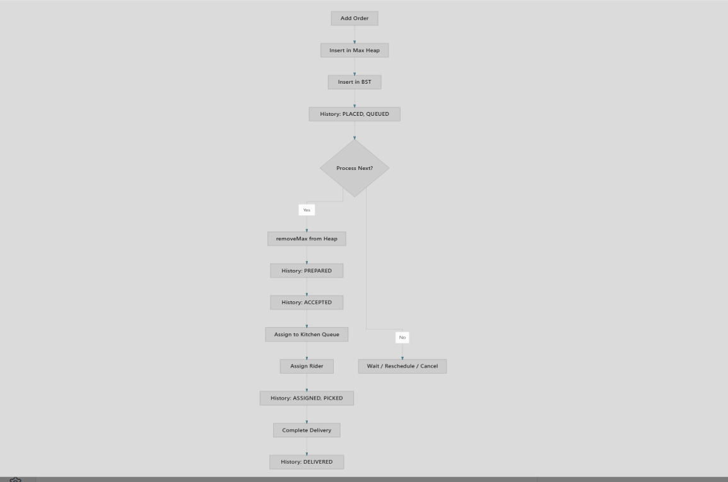

6.2 Dynamic Rescheduling Flow

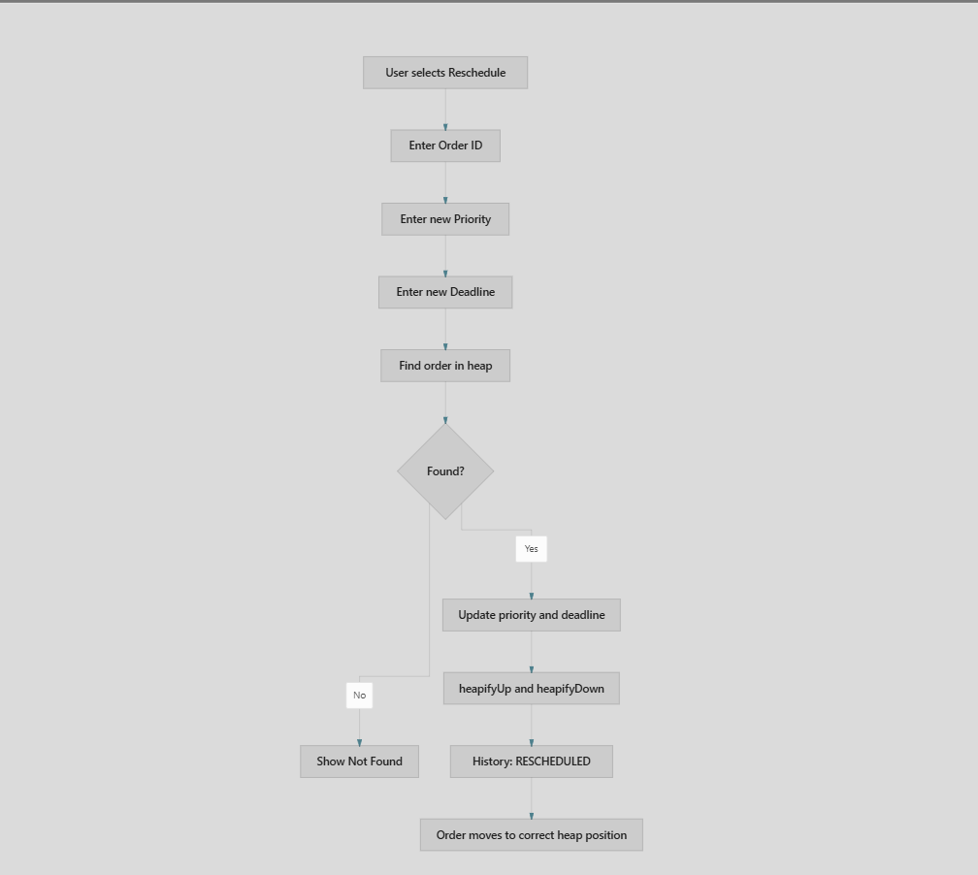

6.3 Rerouting Flow

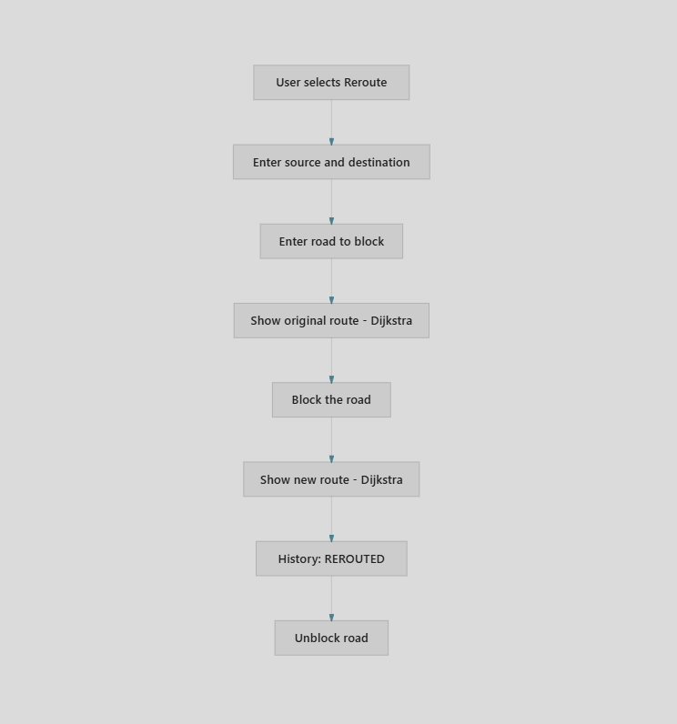

7. Data Structures Used
Data Structure | Class Name | Purpose | Custom?
Max Heap | MaxHeap | Priority order scheduling | Yes
Queue | IntQueue | Kitchen preparation line (FIFO) | Yes
Stack | OrderStack | Undo cancelled orders (LIFO) | Yes
Linked List | HistoryList | Order history and timeline | Yes
BST | BST | Fast search by Order ID | Yes
Graph (Adjacency Matrix) | Graph | City road network | Yes
Array | Multiple | Riders, restaurants, heap storage | Yes
Note: Built-in STL containers (vector, map, priority_queue, stack, queue) are not used, as required by the manual.

8. Algorithms Used
Algorithm | Used In | Purpose
Heap Insert / Extract | MaxHeap | Priority scheduling
Heapify Up / Down | MaxHeap | Maintain heap property after changes
Dijkstra | Graph | Shortest weighted path
BFS | Graph | Level-order traversal of city map
DFS | Graph | Depth-first traversal of city map
BST Search | BST | Find order by ID
Inorder Traversal | BST | Display all records sorted by ID
Linear Search | BST helpers | Search by name, restaurant, status
Bubble Sort | BST | Sort records for report
Greedy Selection | RiderMgr | Choose best available rider

9. Time Complexity Analysis
Module | Operation | Time Complexity | Space Complexity
Max Heap | Insert | O(log n) | O(n)
Max Heap | Extract Max | O(log n) | O(1)
Max Heap | Cancel / Update | O(n) find + O(log n) heapify | O(1)
Max Heap | Reschedule | O(n) find + O(log n) heapify | O(1)
Linked List | Add history | O(1) | O(n)
Linked List | Timeline / Filter | O(n) | O(1)
Stack | Push / Pop | O(1) | O(n)
Queue | Enqueue / Dequeue | O(1) | O(n)
BST | Insert / Search | O(log n) average | O(n)
BST | Inorder display | O(n) | O(1)
Bubble Sort | Sort records | O(n²) | O(1)
Graph | Dijkstra | O(V²) | O(V)
Graph | BFS / DFS | O(V + E) | O(V)
Kitchen | Assign / Rebalance | O(R) | O(R)
Rider | Assign | O(R) | O(R)
Where: n = orders, V = graph nodes, E = edges, R = restaurants/riders

10. Memory Usage Analysis
Component | Size | Description
Order object | ~80–120 bytes | Depends on string lengths
Max Heap array | 100 × sizeof(Order) | Fixed array for active orders
Graph matrix | 8 × 8 × 4 = 256 bytes | Adjacency matrix of distances
Block matrix | 8 × 8 × 1 byte | Blocked road flags
Undo Stack | 20 × sizeof(Order) | Cancelled orders for undo
Kitchen Queue | 50 × 4 bytes per restaurant | Order IDs waiting for prep
History Linked List | Dynamic | One node per history event
BST | Dynamic | One node per search record
Memory is mostly fixed-size arrays for heap, graph, riders, and restaurants. History and BST grow dynamically as orders are added.
Scalability Note: For a real large-scale system, adjacency list + priority queue would use less memory than adjacency matrix. Our design suits a prototype with limited city size.

11. Experimental Performance Results
Run these from Menu 7 and Menu 8 during demonstration:
Test | Input | Expected Observation
Insert test | N = 100 | Time increases slowly (O(n log n))
Delete test | N = 100 | Similar logarithmic behavior
Scalability | N = 10, 20, 50, 100 | Time grows as N increases

12. Menu Structure
FoodExpress Dispatch Optimization Engine
1. Dynamic Order Scheduling
2. Kitchen Load Analysis
3. Rider Dispatch Optimization
4. Route Optimization
5. Search and Retrieval Engine
6. Order History Tracking
7. Performance Analysis
8. Scalability Simulation
9. System Reports
10. Exit

13. Ethical and Professional Practices

13.1 Data Privacy
Customer names, order details, and delivery locations are stored only in program memory during execution. In a production system, this data must be encrypted and access must be restricted to authorized personnel only.

13.2 Data Minimization
Only necessary information (order ID, customer name, restaurant, priority, deadline) is collected. Extra personal data should not be stored without purpose.

13.3 Rider Location Tracking
Rider location is used for dispatch optimization. In a real application, riders must be informed and must consent before their location is tracked or shared.

13.4 Fair Priority Scheduling
VIP and Regular categories affect order priority. This must be applied consistently and transparently so that no customer group is unfairly disadvantaged without clear policy.

13.5 Security in Real Deployment
A real FoodExpress system would require:
- Encrypted database storage
- Secure login and authentication
- Audit logs for order changes
- Compliance with data protection regulations

13.6 Scalability Responsibility
As order volume grows, the system must be upgraded (e.g., adjacency list graphs, balanced trees, distributed queues) to maintain performance without service degradation.

14. Sample Test Scenario

14.1. Add Order

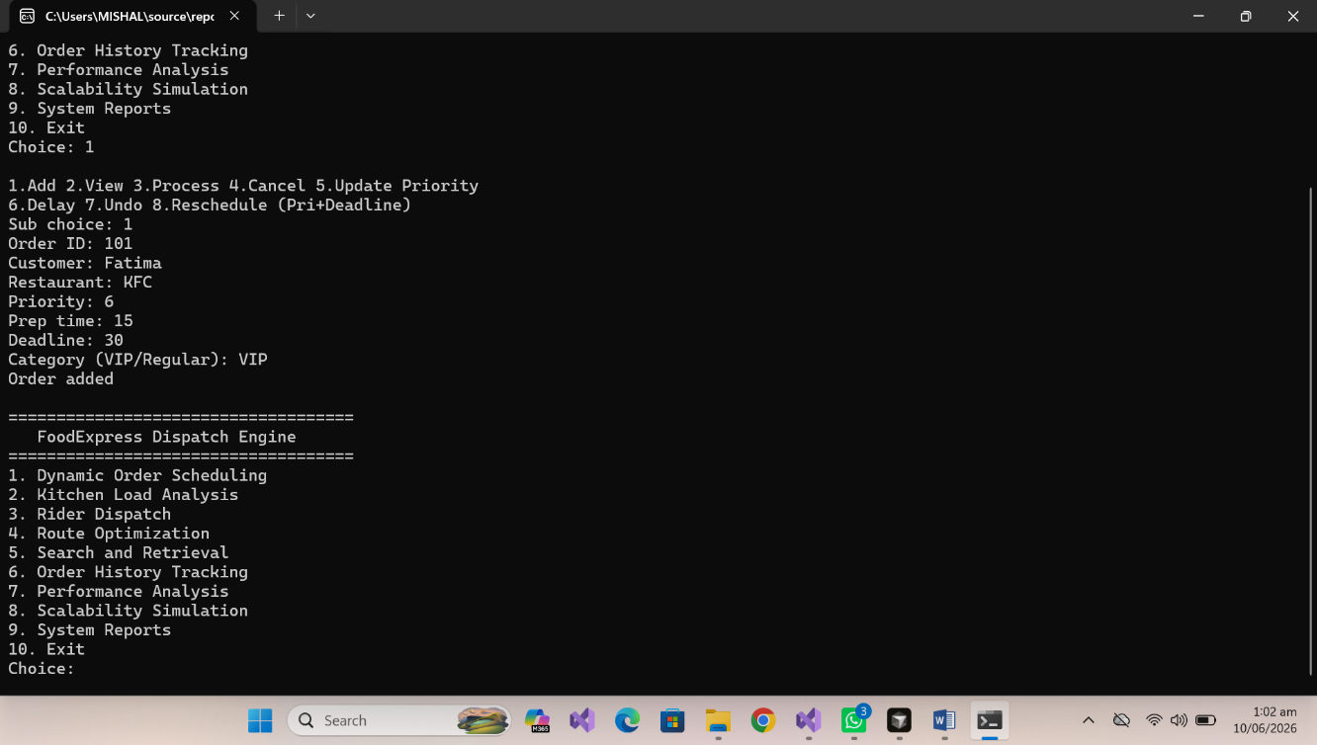

14.2. View Order

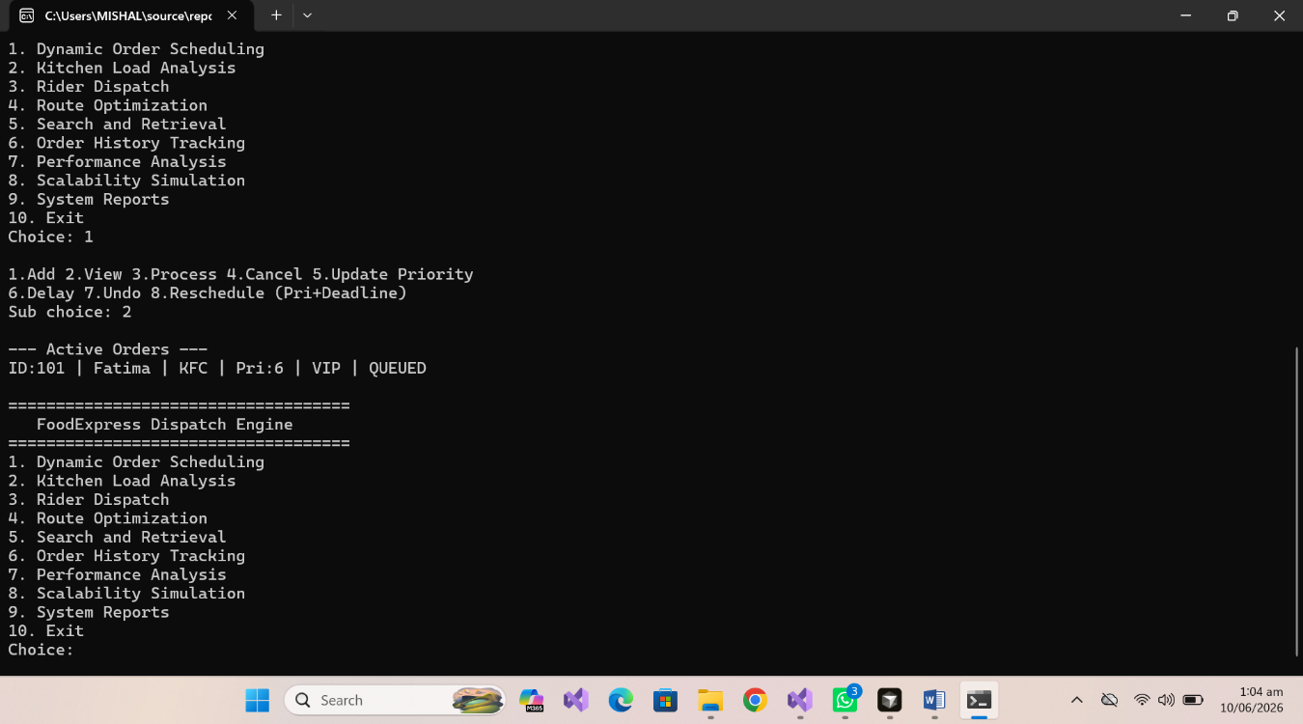

14.3. Process Order

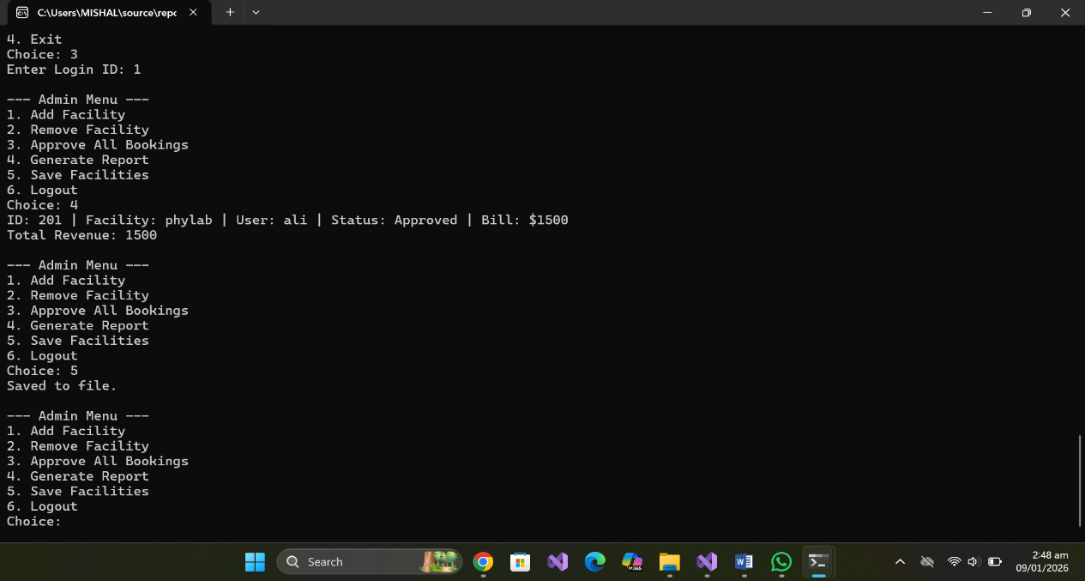

14.4. Search Order

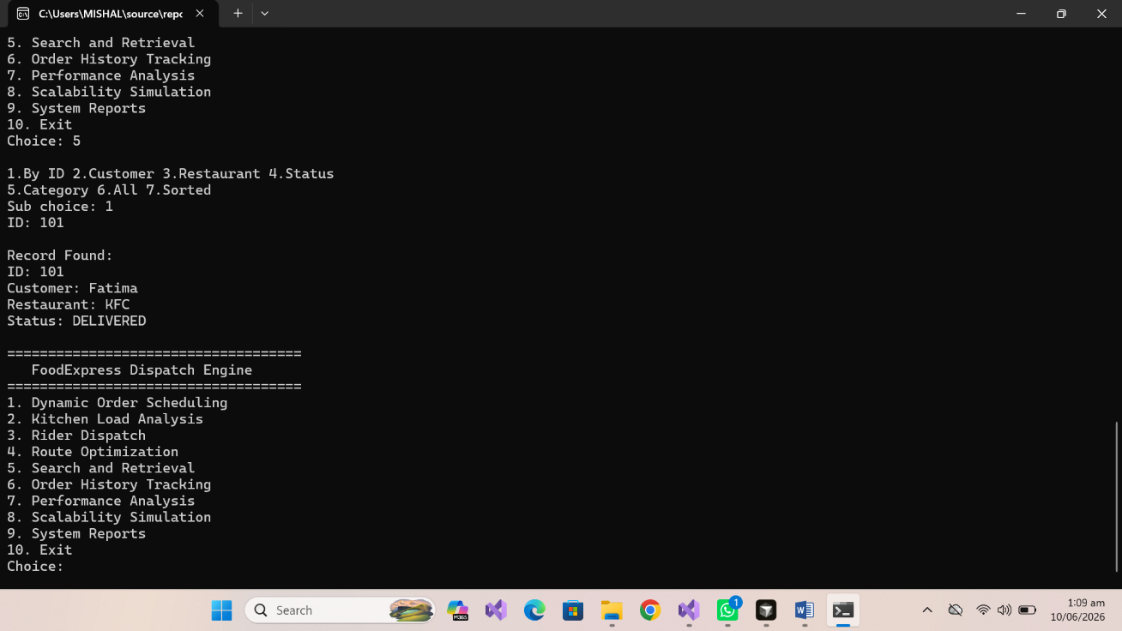

14.5. History tracking

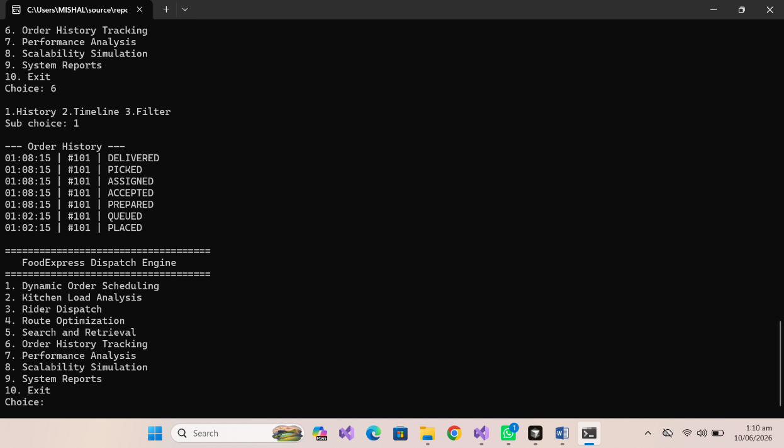

14.6. Kitchen Status

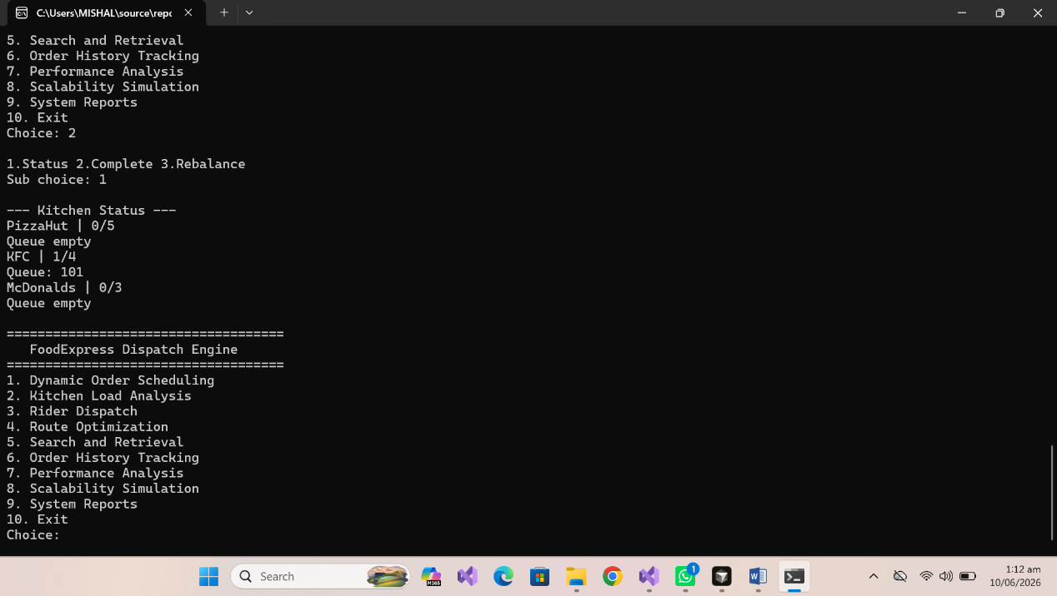

14.7. Route Optimization

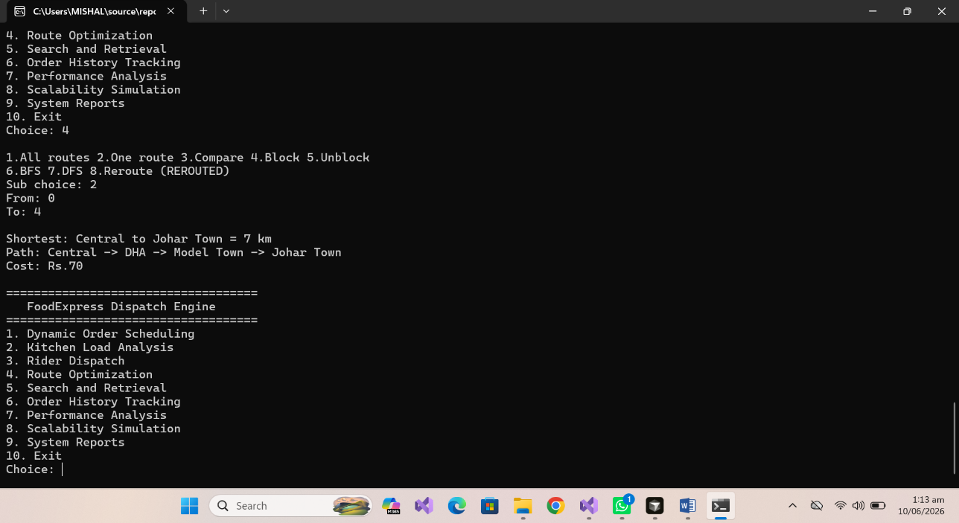

14.8. BFS

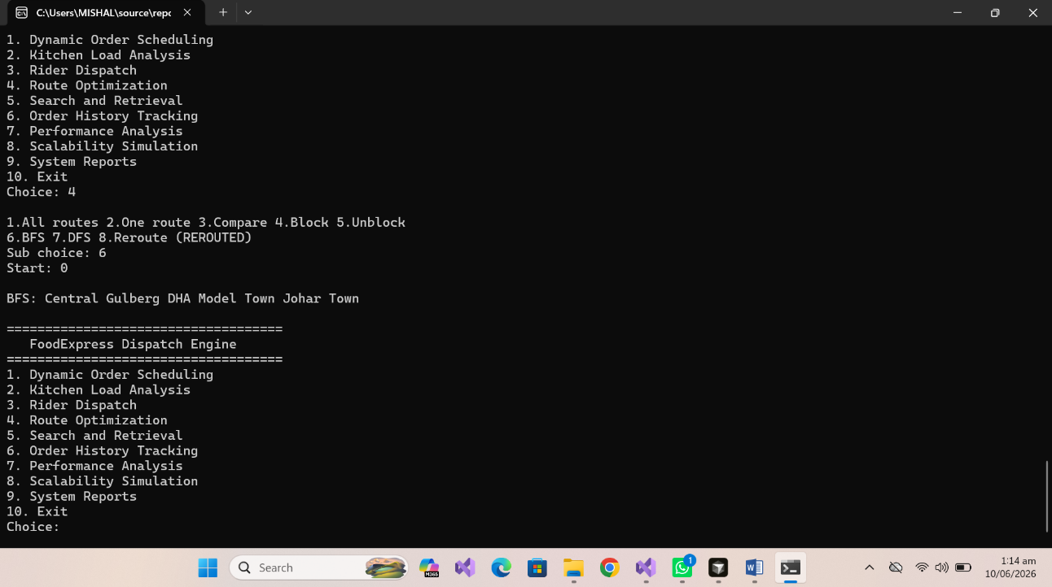

14.9. DFS

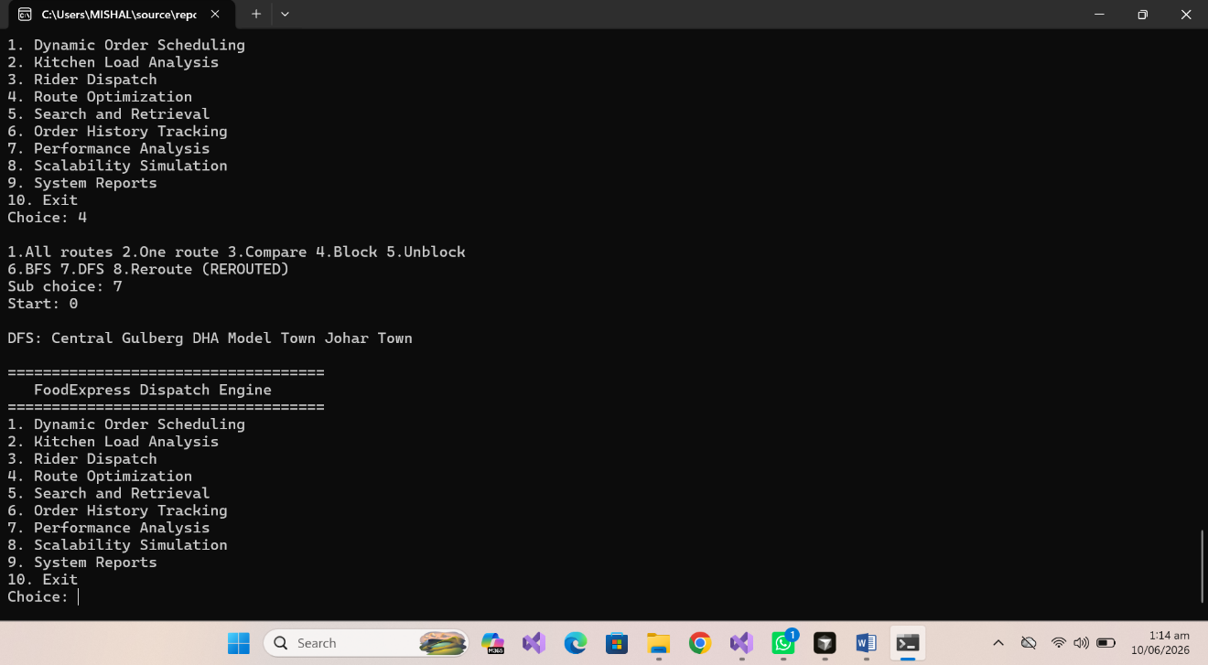

15. Conclusion
This project successfully implements the FoodExpress Dispatch Optimization Engine as required by the CSC-200L OEL manual. All major modules are functional:
- Dynamic order scheduling with heap-based priority and rescheduling
- Kitchen load balancing with queue and rebalance
- Rider dispatch with greedy assignment
- Route optimization using graph, Dijkstra, BFS, DFS, and rerouting
- BST-based search with sorting and filtering
- Linked list history with stack-based undo
- Performance and memory analysis with scalability testing
All data structures are implemented manually without built-in STL containers, demonstrating practical understanding of data structures and algorithms at the undergraduate level.

16. References
- CSC-200L Open Ended Lab Manual, UET Lahore
- Course lectures: Heaps, Trees, Graphs, Searching, Sorting
- Textbook: Data Structures and Algorithms concepts (Heap, BST, Graph traversals)

